Race Sorter – QuickSort Visualization Game
Algorithm Racing & Sorting Visualization Project Report

By:
Daniyal Asghar

SAP:
53731
Instructor:
Mr. Muhammad Usman Sharif

Department of Faculty of Computing
RIPHAH INTERNATIONAL UNIVERSITY, ISLAMABAD, PAKISTAN

Contents:
- Introduction
- Problem Statement
- Objectives
- Project Scope
- Tools & Technologies Used
- Algorithms Used o Randomized QuickSort o Deterministic QuickSort o Median Finding
- Time Complexity Analysis
- Game Design o User Interface o Racing Mechanics o Sorting Visualization
- Implementation Details o Code Structure o Key Functions
- Real-World Applications
- Challenges & Solutions
- Conclusion
- GITHUB link

1. Introduction
Race Sorter is an interactive visualization game developed using Python and Pygame. In this game, each racer car's attributes (Speed, Acceleration, Handling) are combined to calculate a sort value, which is used by the QuickSort algorithm to determine the racer order.
The purpose of the game is to help students:
- Visually understand sorting algorithms
- Observe the effect of pivot selection
- Learn the difference between Randomized and Deterministic QuickSort
- Visualize algorithm steps in a racing context
This project combines racing with algorithm learning, making sorting intuitive and engaging.

2. Problem Statement
Students often find it difficult to understand QuickSort concepts like pivot selection, partitioning, lane swapping, and randomized vs deterministic behavior in theoretical form.
Visual representation of sorting steps can serve as an effective teaching method.
Race Sorter addresses this by mapping:
- Racers = array elements
- Lanes = array indexes
- Lane swaps = array swaps
- Median racer boost = algorithmic insight
- Race progress = sorting effect

3. Objectives
The main objectives are:
- Demonstrate QuickSort algorithm visually
- Explain Randomized vs Deterministic pivot selection
- Integrate racing mechanics with sorting
- Provide median racer a temporary boost for insight
- Highlight sorting operations graphically
- Develop an educational and entertaining interface

4. Project Scope
The project focuses on educational and interactive visualization:
- Comparison of sorting algorithms
- Pivot visualization
- Real-time racer movement
- Median element power boost

5. Tools & Technologies Used
Tool / Library | Purpose
Python 3.x | Core programming
Pygame | Graphics, animation, rendering
Enum | Algorithm mode definition
Random | Random pivot selection, attributes
Time Module | Finish time measurement
Math Module | Minor calculations

6. Algorithms Used

6.1 Randomized QuickSort
- Pivot is randomly chosen.
- Provides better average-case performance.
- Pivot is highlighted with a yellow border.
Steps:
- Random pivot selection
- Swap with low index
- Partition subarray
- Recursively sort subarrays

6.2 Deterministic QuickSort
- Pivot is always the last element.
- Worst-case O(n²) is possible.
- Predictable execution.

Steps:
- Choose last element as pivot
- Partition subarray
- Recursively sort subarrays

6.3 Median Finding
The median racer is identified using order statistics:
median = sorted(racers by sort_value)[n // 2]
Median racer gets a 3-second power boost, demonstrating the concept of median-of-three pivot selection.

7. Time Complexity Analysis
Algorithm | Best | Average | Worst
Randomized QuickSort | O(n log n) | O(n log n) | O(n²)
Deterministic QuickSort | O(n log n) | O(n log n) | O(n²)
Partition Function | O(n) | O(n) | O(n)

8. Game Design

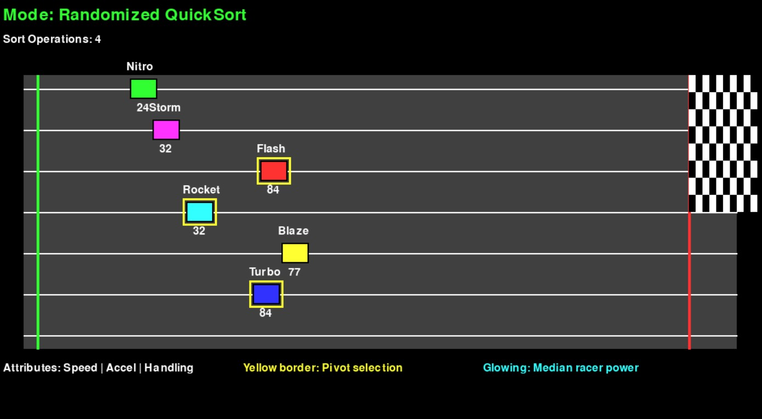

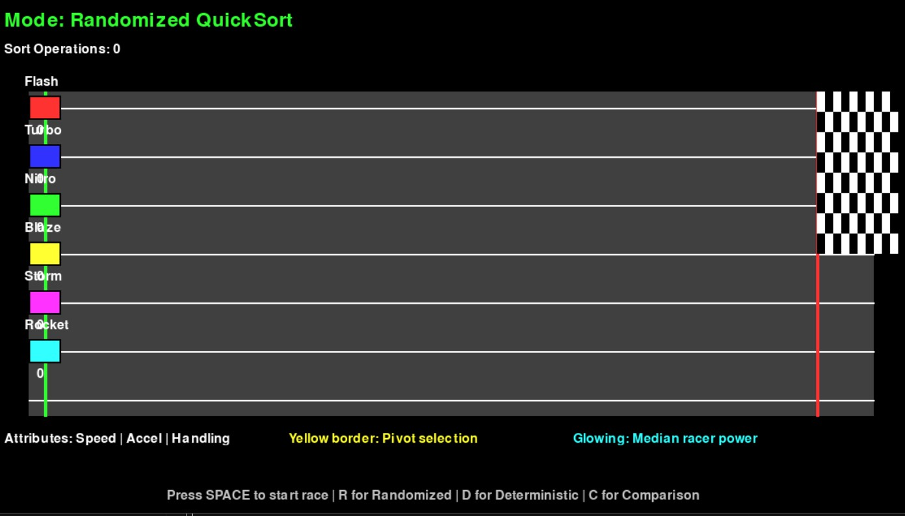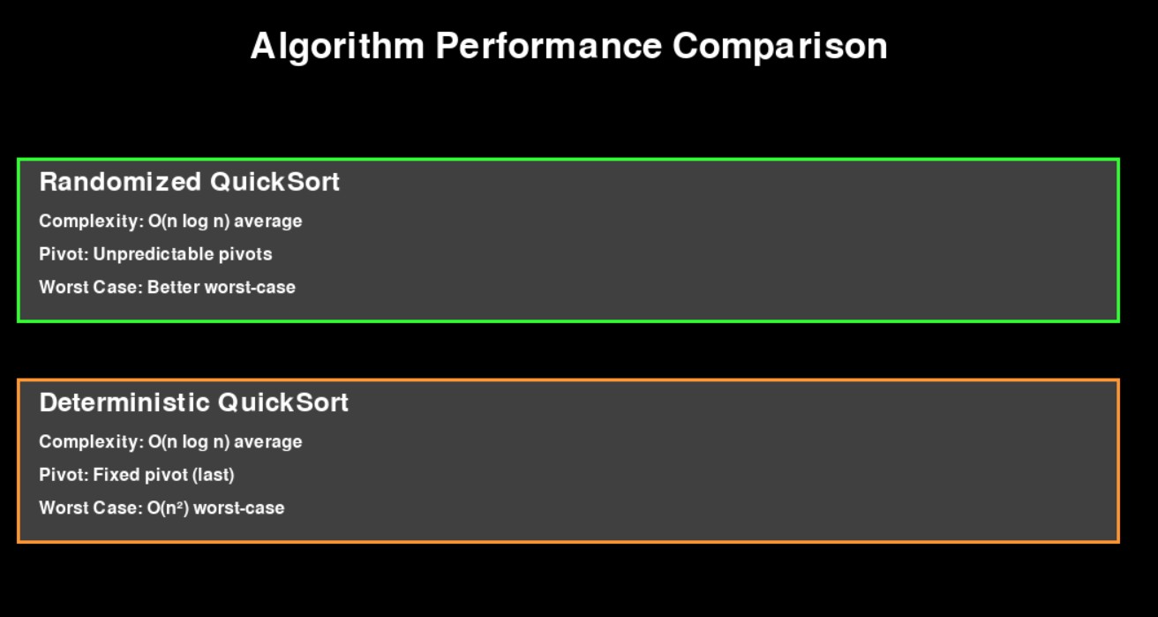

8.1 User Interface Design UI elements include:
- Track with 6 racing lanes
- Start line, finish line, checkered flag
- Racer names and stats (Speed, Acceleration, Handling)
- Sort operation counter
- Side legend
- Pivot highlight box
- Finish order leaderboard

8.2 Racing Mechanics
- Racers accelerate based on their attributes
- Median racer gets temporary turbo boost
- Handling introduces slight randomness
- Racers stop at finish line
- Finish times are recorded

8.3 Sorting Visualization Sorting affects:
- Racer lane positions
- Pivot highlights
- Swap animations via lane switches
- Randomized vs Deterministic pivot behavior

9. Implementation Details

9.1 Code Structure
Component Description
Racer class Stores attributes, movement logic, sort value RaceSorterGame class Main controller
quicksort_randomized() Random pivot QuickSort quicksort_deterministic() Last-element

pivot QuickSort
partition() | Lane swapping visualization
draw_racers() | Draw cars with pivot highlight
update() | Racer movement and boost logic

9.2 Key Functions
calculate_sort_value() – Combines racer attributes for sorting. partition() – Performs array swap, visually represented as lane swap. activate_power() – Gives median racer temporary boost.
start_race() – Applies sorting and initiates race.
draw_comparison() – Shows performance comparison of Randomized vs Deterministic QuickSort.

10. Real-World Applications
- Teaching sorting algorithms
- Visual algorithm education tools
- AI/ML data ordering systems
- Animation-based learning modules
- Game-based learning

11. Challenges & Solutions
Challenge Solution
Pivot visualization Yellow highlight border
Lane swapping clarity Animated lane assignments
Attribute balancing Weighted formula for sort values
Algorithm comparison Dedicated comparison screen
Median racer insight Special power mechanism

12. Conclusion
Race Sorter is an engaging educational project that:
- Demonstrates QuickSort visually and intuitively
- Explains Randomized vs Deterministic pivot behavior
- Uses race mechanics to showcase sorting steps interactively
It can be extended into a multi-algorithm educational platform for teaching purposes.

GITHUB LINK

